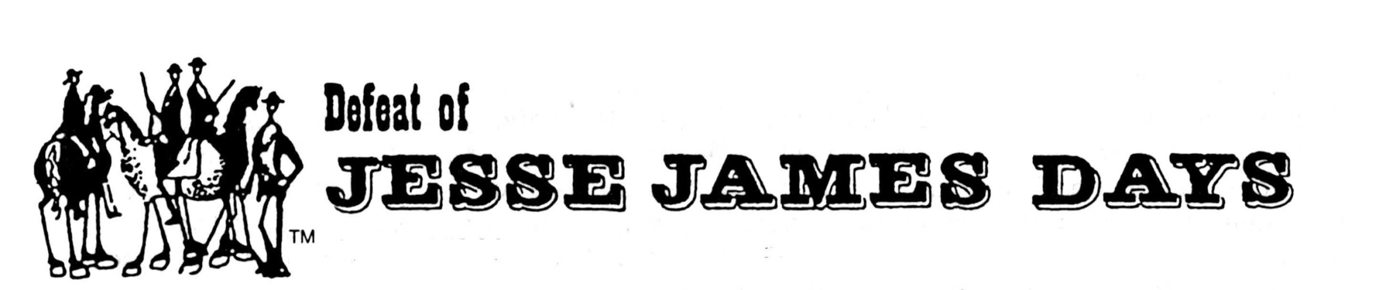

GREETINGS FROM NORTHFIELD, MINNESOTA

The Defeat of Jesse James Days Committee is currently planning its 2022 celebration, commemorating the townspeople’s defeat of the James/Younger Gang in 1876

On behalf of the Committee we are pleased to invite you to submit an application to participate in our Grand Parade. We are proud to continue our tradition of presenting one of the finest parades in the state.

The parade will be Sunday, September 11, 2022 beginning promptly at 2:00 P.M.

The parade will line up at the Northfield High School on the south edge of town and proceed north for a distance of 12 blocks.

When completing the enclosed application, please be very specific as to the number of units, cars, groups and length of the space you will need to line-up and participate in our parade. Make your application very complete and include information about your unit or organization for the script for the announcers. Identification signs should be of professional quality and durability.

Rules and regulations for parade participation:
- The purpose of the parade is entertainment. The Committee does not discriminate against any units on the basis of race, creed, religion, sex, National origin or sexual preference. However, since the creation of the parade is a matter of aesthetics, we have the right to reject any unit without a stated reason. As a general rule, we do not accept political, religious or social action units.
- Absolutely no throwing of candy from parade unit, however, you may hand it to viewers while walking the parade route. Do not cause gaps in the parade.
- No discharging of firearms of any kind except for the James/Younger Gang.
- Only approved commercial signs may be displayed upon receipt of a $600 fee. This fee will be assessed to you if any commercial advertising is found on your unit during any part of the parade.
- No large gaps between units during parade.
- All units to proceed on the parade route in a continuous forward motion. No circling or large gaps caused by performances by your unit are allowed!
- The Defeat of Jesse James Days Committee and the City of Northfield require proof of liability insurance with a loss payable clause listing both parties before your unit is accepted to participate in the parade. Information about the proof of liability insurance can be found at http://www.djjd.org/waivers/
- Waivers will be required for all participants in your unit. You can download a copy of this waiver at http://www.djjd.org/waivers/
- Please make copies for your participants to sign and return before August 26, 2022.
- All participants MUST sign a waiver!!!

A VIOLATION OF ANY OF THESE RULES MAY RESULT IN YOUR UNIT BEING PULLED FROM THE PARADE AND EXCLUSION FROM THE PARADE THE FOLLOWING YEAR.

If you would like us to consider you or your group for participation in the 2022 Defeat of Jesse James Days Grand Parade.
Please fill out the attached application and return it to us immediately, but no later than Sunday, July 31, 2022. The parade is limited to approximately 130 units. You will be notified of your unit’s line up number during the last week of August 2022.

Applying for a spot in the parade does not guarantee a spot as the DJJD Parade has more applications then parade spots available.

Return Applications
By E-mail: djjdparade@gmail.com
By mail:
The Defeat of Jesse James Days Grand Parade

P.O. Box 23, Northfield, MN 55057

Any questions please contact
Parade Chair Dave Smith- 651-564-1109

