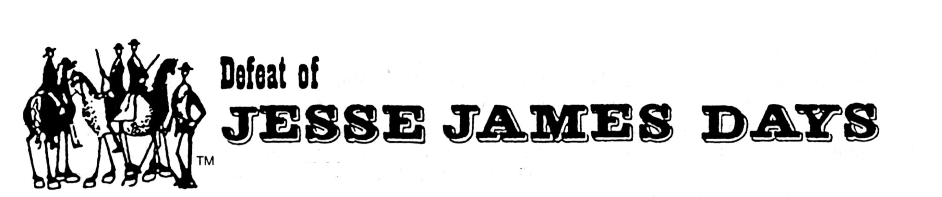

Release and Waiver of Claims for
2021 Grand Parade.

We hereby release and forever discharge the Defeat of Jesse James Days Committee, Inc. (hereinafter referred to as “Committee”), Sponsors, and the City of Northfield, its officers and employees (hereinafter referred to “the City”), their agents employees and officers, from all claims, demands, actions, judgments and executions that may arise all claims that I or my child may have or which my child’s heirs, executors, or assigns may have against the Committee or the City for all personal and property injuries caused by, or arising out of participating in the Defeat of Jesse James Days Grand Parade.

I acknowledge the inherent dangers involved in riding on a float, walking in the parade, riding a horse in the parade or riding a vehicle in the parade, including the dangers created by falling off a moving vehicle or horse or other motor vehicle traffic, street conditions and other participants. I understand and agree that no one will be able to hold the above-named parties liable for any injuries to me or my child.

This release does not apply to injuries caused directly by the willful misconduct to the Committee or the City.

I have read this release and understand all of its terms and voluntarily execute this release.

Dated: _________________ ___________________________
(Signature of Participant)

Dated: _________________ ___________________________
(Signature of Parent if Participant is Under age of18)

Dated: _________________ ___________________________
(Name of Organization or Parade Unit)

