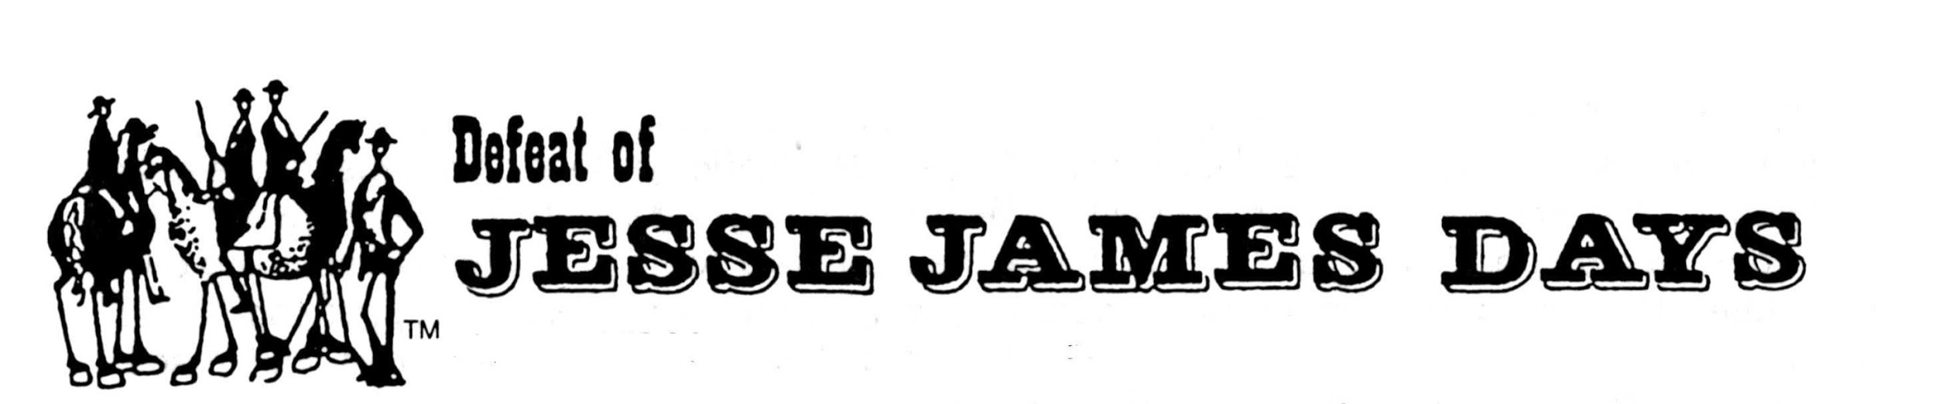

2021 Grand Parade Band Information
Sunday, September 12, 2021 – 2 p.m.

High School Name: ____________________________________________________________
Director/Contact Name__________________________________________________________
Address: _____________________________________________________________________
City, State, Zip: ________________________________________________________________
Phone (Day): _________________________________________________________________
(Evening): ______________________________________________________________
Fax: _________________________________________________________________________
E-Mail: ______________________________________________________________________

Unit Information
Approx. number of band members in Unit __________
(This will assist us in having adequate bottles of water available at end of the parade.)
Number of Buses ____________
(Information needed for facilitating band pick-up at end of parade)

Fee charge or traveling expense for unit: _______________________________________
Description of Unit (Information about the band that the announcer can use as an introduction)
____________________________________________________________________________
____________________________________________________________________________
____________________________________________________________________________
____________________________________________________________________________
____________________________________________________________________________

SPECIAL NEEDS or COMMENTS: ________________________________________________
_____________________________________________________________________________
_____________________________________________________________________________
_____________________________________________________________________________

Completed APPLICATIONS must be submitted no later than August 1, 2021.

