Defeat of Jesse James Days
Junior Ambassador Candidate Information

Name: ________________________________________________

Age: ___________________ (As of August 12, 2016)

Parent/Guardian:____________________________________________________________

Address: ___________________________________________________________________

Phone: _____________________________________________________________________

Email: _____________________________________________________________________

Sponsor: ____________________________________________________________________

_________Please provide one for us

Candidate’s Interests and Hobbies: ______________________________________________________________________________

______________________________________________________________________________

______________________________________________________________________________

Favorite activity during Celebration Weekend: _____________________________________

______________________________________________________________________________

Talent Candidate will be performing (PLEASE LET ME KNOW IF THIS CHANGES):

_____________________________________________________________________________

______________________________________________________________________________
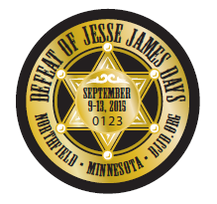

By entering my child in the DJJD Junior Ambassador Coronation. I agree that if my child is crowned I will support and follow the rules and regulations of the DJJD Committee.

__________________________________________ ______________________________
Parent/Guardian Signature Date

Please return form by July 15, 2016 to:
Tina Lemke, Jr. Ambassador Chair
P.O. Box 23
Northfield MN 55057
(612) 227-8846
tinalemke@ymail.com

