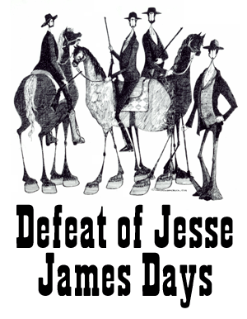

In consideration of my candidacy for the Defeat of Jesse James Days Ambassador Scholarship Program:
I, _______________________________________________________________ (Name)
(City) ____________________________________ State of _________________, do hereby
agree that:
- I have voluntarily entered the contest for Defeat of Jesse James Days Ambassador at my own risk.

- I have read the Candidate and Ambassador Handbook; I have completed the application, and I have entered this contest subject to all its rules and regulations.

- I will be at least 17 years of age by July 15th of this year; am single and not engaged to be married; and live and/or work in the Northfield School District #659.

- I hereby authorize and permit the Defeat of Jesse James Days Committee, Inc., a Minnesota nonprofit corporation (hereinafter referred to as the “Committee”) and/or any participating organization, its officers, members and sponsors to use my name and picture for promotional purposes during the period of my candidacy, the Defeat of Jesse James Days (hereinafter the “Celebration”) and thereafter, provided that my name and picture shall be at all times used for publicity purposes only.

- If I am chosen as a Defeat of Jesse James Days Ambassador; I agree to come and remain under the sole control of the Committee and its appearance coordinator, and to follow Celebration Policies. I shall relinquish all other titles bestowed upon me, and in consideration therefore, I agree to be publicized as a Defeat of Jesse James Days Ambassador. I will cooperate fully with the Committee and coordinator in all functions and public relations programs and appearances, as the Committee and coordinator see fit, without any claims for compensation.

- If selected as an Ambassador, I will restrict my work and personal activities during my candidacy to allow me to attend all Celebration appearances, functions, and trips, throughout my candidacy and year of reign; I will not make any commercial appearances as a candidate or as an Ambassador unless authorized by the Committee and/or coordinator.

7. Any candidate may be dismissed from competition at the sole discretion of the Committee.

I do hereby release and forever discharge the Committee, its officers, members and sponsors and the City of Northfield (hereinafter City), its officers and employees, from any and all liabilities direct or indirect, for personal injury or property damage which I may suffer during the Celebration, including the time of the contest for Defeat of Jesse James Days Ambassador, and, in the event I am chosen as an Ambassador, then during the year of my reign. This Release shall not be effective if the injuries are caused directly by the willful misconduct of the Committee, its officers, members and sponsors.

____________________________________
Dated

____________________________________
Printed name of Contestant

____________________________________
Signature of Contestant

____________________________________
Signature of Parent or Legal Guardian (if Candidate is
is not 18 years of age).

